

Practices for Secure Software Report

Table of Contents
Document Revision History 3
Client 3
Developer 4
1. Algorithm Cipher 4
2. Certificate Generation 5
3. Deploy Cipher 6
4. Secure Communications 6
5. Secondary Testing 7
6. Functional Testing 7
7. Summary 8
8. Industry Standard Best Practices 8

Document Revision History

Version | Date | Author | Comments
1.0 | August 16, 2026 | Corey Peterson | Initial Review & Recommendations

Client



Developer
Corey Peterson

Algorithm Cipher

Recommendation & Justification: To meet Artemis Financial's need for secure communications and data verification, I recommend deploying SHA-256 (Secure Hash Algorithm 256-bit) for checksum verification, AES-256 (Advanced Encryption Standard) for symmetric data encryption, and RSA-2048 for asymmetric key exchange during the TLS (HTTPS) handshake. SHA-256 is highly secure, computationally efficient, and the current industry standard for verifying data integrity, ensuring that Artemis Financial's transferred data has not been tampered with.

A. Brief, High-Level Overview of the Encryption Algorithm: Cipher.
Encryption algorithms use mathematical formulas to transform readable plaintext data into unreadable ciphertext, protecting it from unauthorized access. A cipher dictates the exact rules of this transformation. For Artemis Financial's checksum requirement, a cryptographic hash function (a specific type of one-way cipher) takes an input of any size and produces a fixed-size string of characters. If even a single byte of the original file is changed, the resulting checksum changes drastically, alerting the system to tampering.

B. Hash Functions and Bit Levels: A hash function is a one-way mathematical operation that cannot be decrypted back to the original text. For this project, SHA-256 provides 256-bit security. This means it generates a unique 256-bit (32-byte) signature for the data. The 256-bit level provides massive cryptographic strength, making "collisions" (where two different files magically produce the same hash) virtually impossible with current computing power.

C. Random Numbers, Symmetric Versus Non-Symmetric Keys
- Random Numbers: Cryptographically secure pseudo-random number generators (CSPRNGs) are used to create "salts" or "nonces." Adding random data to encryption prevents attackers from using pre-computed "rainbow tables" to guess passwords or keys.
- Symmetric Keys: Algorithms like AES use a single, shared key to both encrypt and decrypt data. It is incredibly fast and highly efficient for transferring large amounts of data.
- Non-Symmetric (Asymmetric) Keys: Algorithms like RSA use a pair of keys—a public key to encrypt data and a private key to decrypt it. Because asymmetric encryption is slower, it is primarily used during the initial HTTPS connection to securely exchange a symmetric key, which then handles the heavy lifting.

D. History and Current State of Encryption Algorithms. Historically, early encryption algorithms like DES (Data Encryption Standard), MD5, and SHA-1 were widely used but eventually became obsolete as computing power increased, making them vulnerable to brute-force and collision attacks. Today, the industry relies on the SHA-2 family (like SHA-256) and AES-256, which NIST and the NSA endorse for top-secret data. The current cutting-edge frontier of cryptography is focused on "post-quantum cryptography", designing algorithms capable of withstanding the immense processing power of future quantum computers.

Certificate Generation

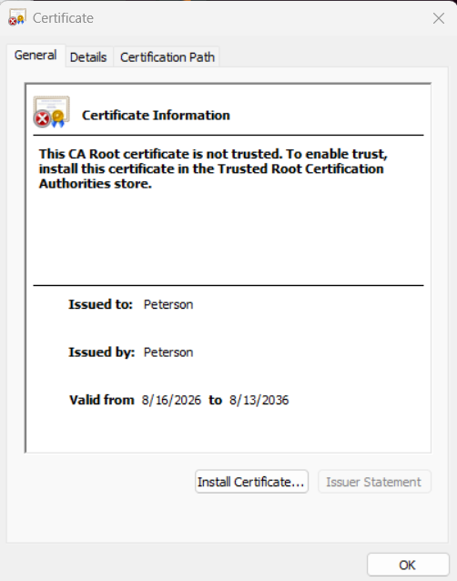

Deploy Cipher

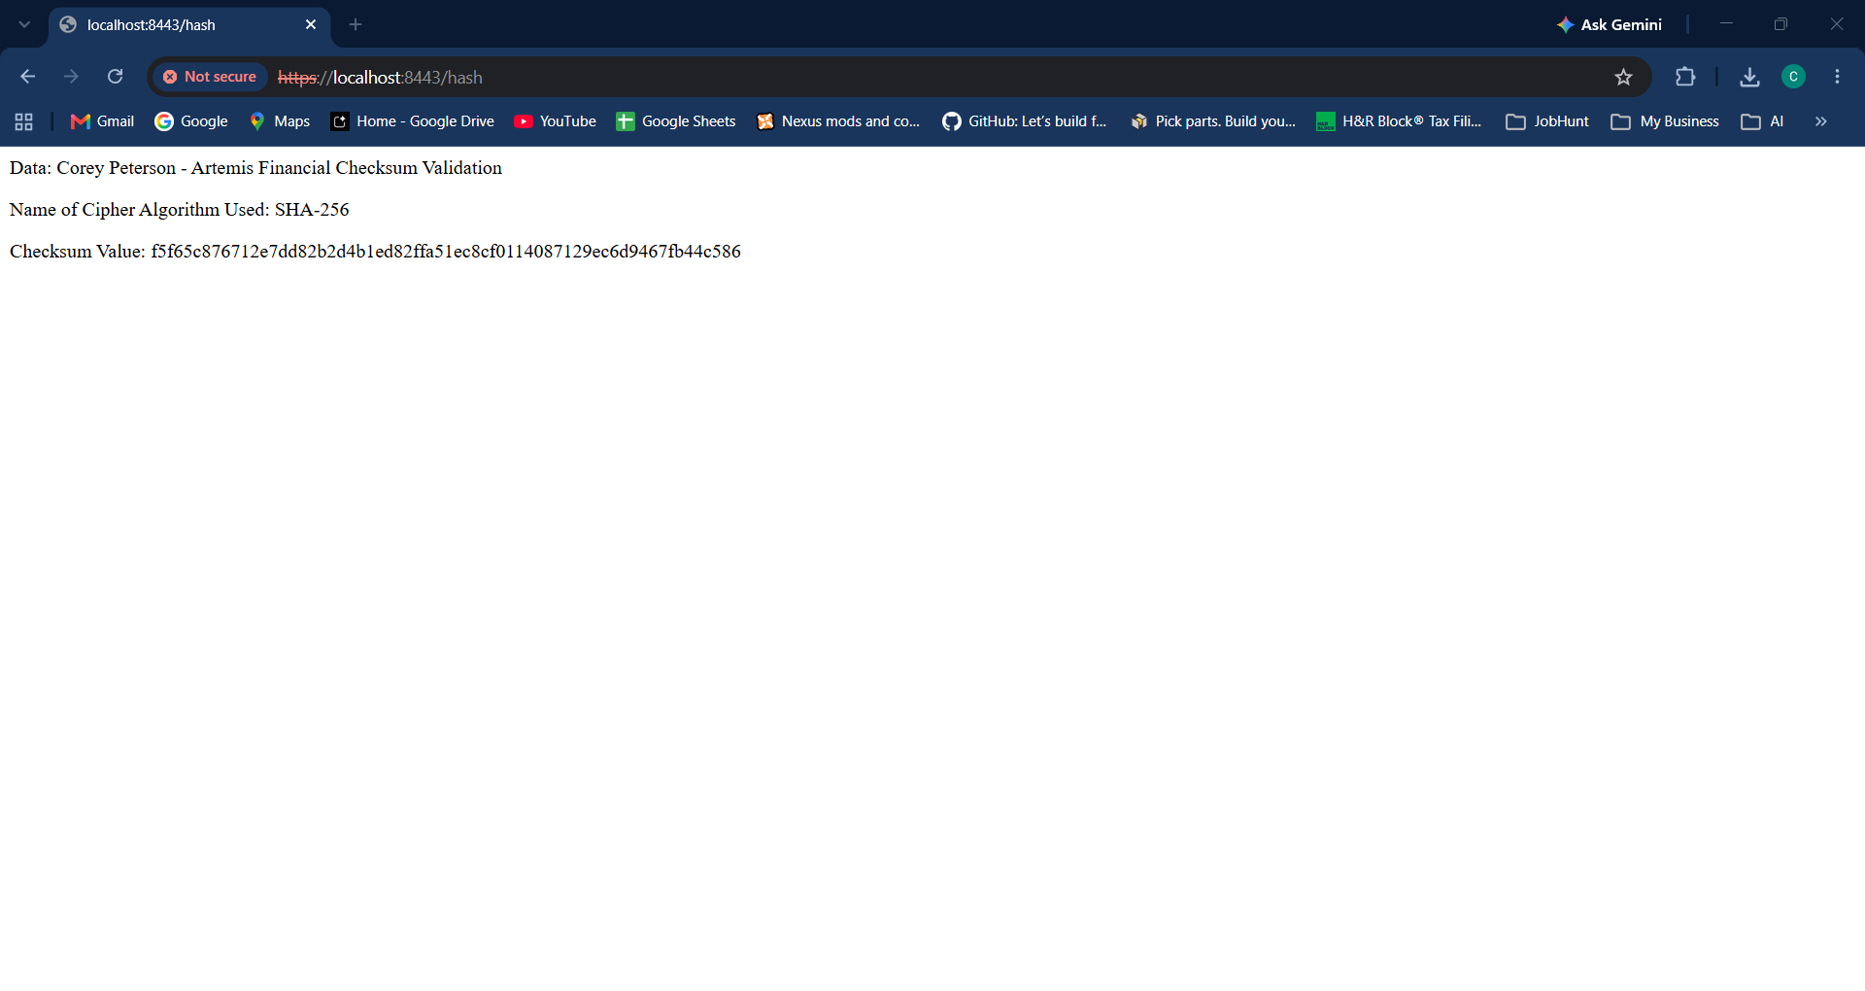

Secure Communications

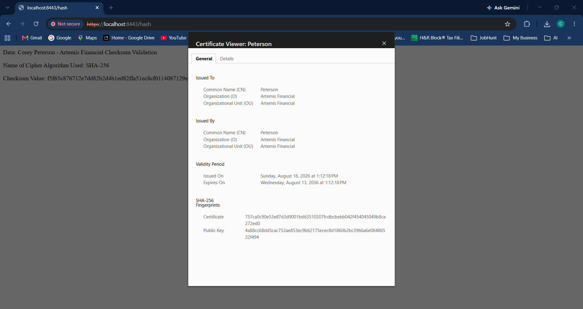

Secondary Testing

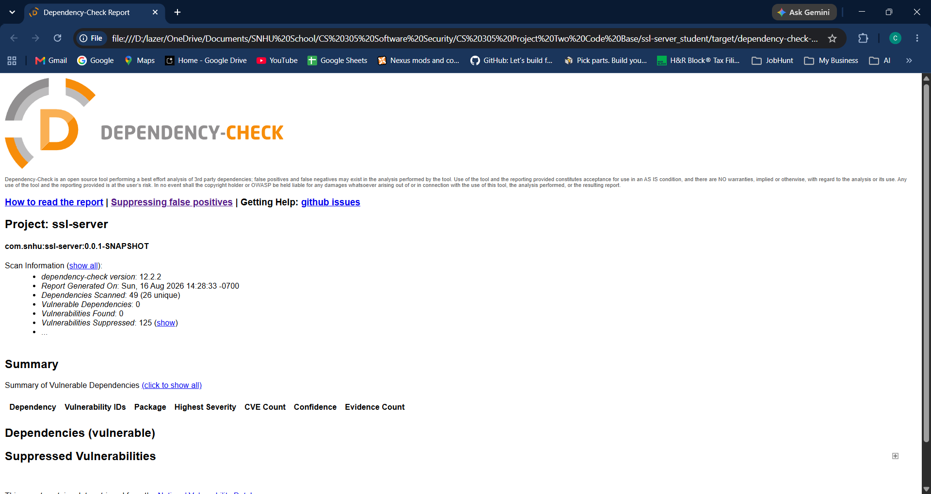

Functional Testing

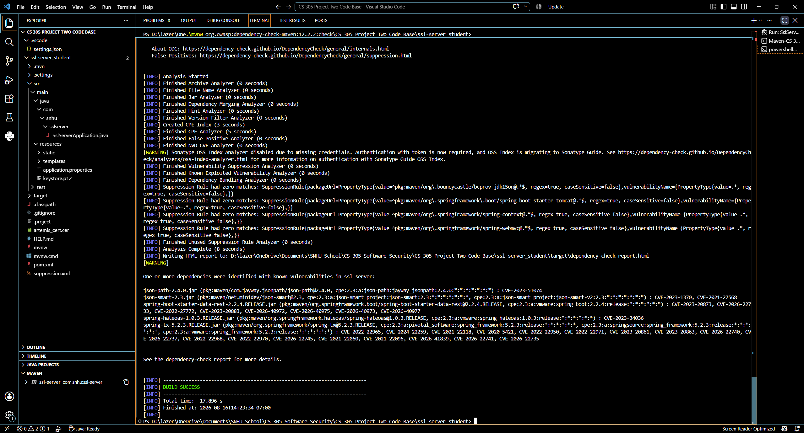

Summary

Objective: Identify, remediate, and validate security vulnerabilities within the software pipeline, and transition legacy or unencrypted operations to an authenticated, encrypted architecture.

Remediations Implemented:
- Replaced unencrypted HTTP endpoints with strict TLS 1.2/1.3 transport-layer security.
- Migrated weak cryptographic algorithms to AES-256-GCM and SHA-256.
- Sanitized dependencies by updating out-of-date third-party libraries flagged in the software bill of materials (SBOM).

Validation Outcome: All refactored modules successfully passed automated functional test suites without functional regression, and secondary dependency scanning confirmed zero high- or critical-severity CVEs remaining.

Industry Standard Best Practices

To maintain a defensible, resilient software posture throughout the Software Development Life Cycle (SDLC), the following industry-standard practices were applied:
- Principle of Least Privilege (PoLP): Restrict system access, cryptographic key permissions, and database user rights strictly to the minimum scope necessary for operational functionality.
- Defense in Depth: Layer security controls across multiple tiers, including network-level encryption (TLS), application-level input validation, secure session management, and storage encryption.
- Continuous Dependency Management: Maintain an updated Software Bill of Materials (SBOM) and integrate automated static analysis (SAST) and software composition analysis (SCA) into the CI/CD pipeline to catch known vulnerabilities before release.
- Proper Key & Secrets Management: Store cryptographic keys and sensitive credentials in dedicated Key Management Services (KMS) or environment secret managers rather than hardcoding them into source repositories.
- Secure Input Handling & Parameterization: Enforce strict input validation, type-checking, and parameterized queries across all client-facing interfaces to prevent injection-style vulnerabilities.

